**Methods**

All the statistical analysis is done with use of R (v. 4.0.5) programming language. The effect of population on higher transportation of H3-IAA in inflorescence shoots is analyzed via classical pairwise-test and non-parametric Wilcoxon Test. After that the work focuses on the differences between species groups. For multiple groups analysis we use ANOVA to check the hypotheses about the difference within all groups and Tukey post hoc tests to investigate differences within each pair of groups. Results of the Tukey post hoc tests a then compared with the results of classical pairwise tests. Finally, we address to the nested ANOVA analysis for additional insights.

Data contains of 36 observations where half of the refer to the Mayodan population and the other half to Spiterstulen population. Each of these is groups is also divided into 3, thus having 6 observations for each species. One observation is omitted in the analyze due to being an outlier.

**Results**

**Checking Assumptions for Parameter**

**Population**

Distribution of auxin transport for Mayodan plants does not pass Shapiro normality test (see appendix), while distribution for Spiterstulen group can roughly be treated as normal. At the same time Levene’s test indicates that two groups’ values are homogenous.

Average disintegration per minute in Mayodan plants exceeds that of Spiterstulen by about 2400 dpm. However, the difference in medias is rather smaller – only 1663,15 dpm (see table 1). As the histogram shows, there a couple of plants showing around 20000 dpm among Mayodan population, which leads to the high gap between mean and median in this group.

Figure (1)

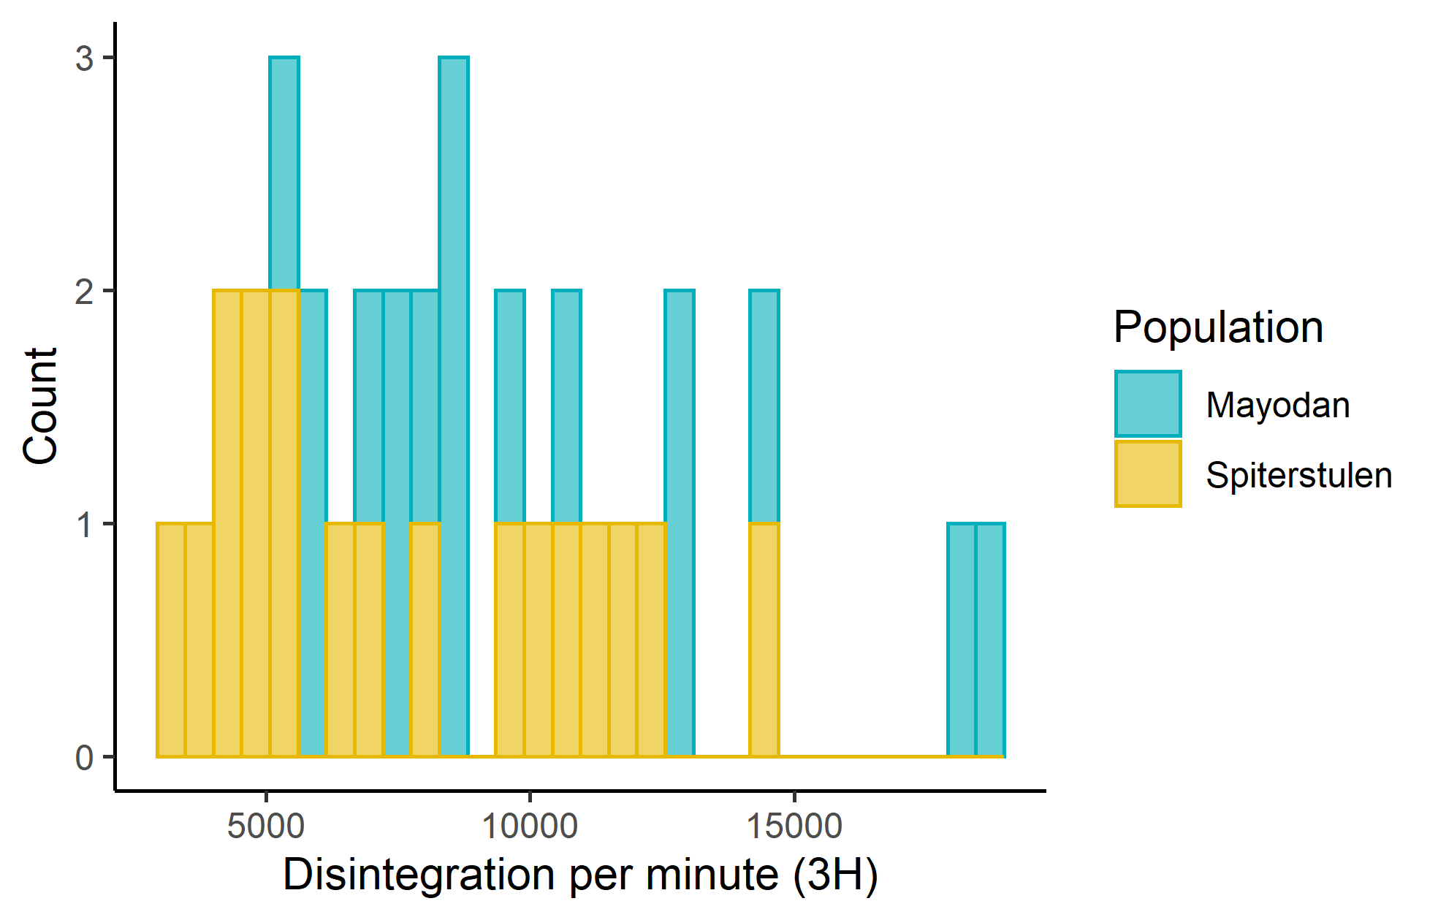

Table(1). Summary Statistics by population

|  |  |  |  |  |  |  |  |
| --- | --- | --- | --- | --- | --- | --- | --- |
| **Population** | **N** | **Mean** | **Std. dev.** | **IQR** | **%25 Q** | **%50 Q** | **%75 Q** |
| Mayodan | 17 | 10022.045 | 4062.547 | 5036.40 | 7634.050 | 8356.310 | 12670.45 |
| Spiterstulen | 18 | 7603.797 | 3458.120 | 5681.84 | 4756.292 | 6693.175 | 10438.13 |

Figure (2)

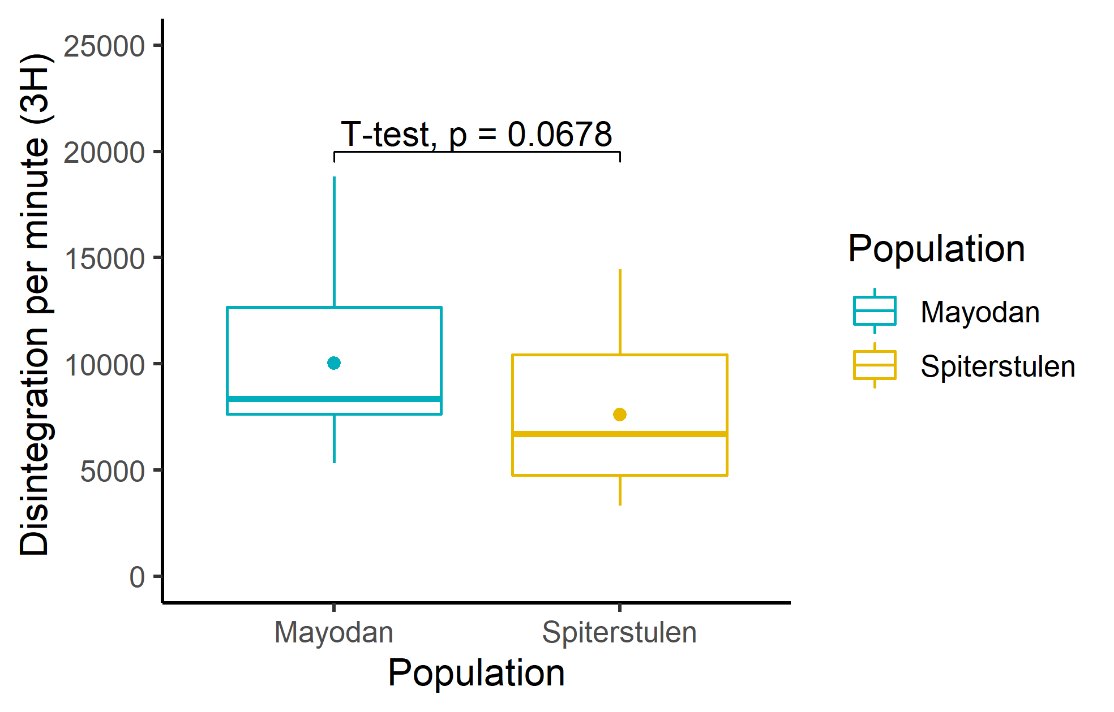

The results of the t-test a represented on the Figure (2) suggest that on the 10% confidence level there is a significant difference between the mean of Mayodan population and Spiterstulen population. However, since assumptions of normal distribution a violated for these groups, non-parametric Wilcoxon test is also conducted (see Table 2). Its results, though, show almost the same picture.

Table (2) Wilcoxon-Test

| **Variable** | $$µ_{Mayodan}$$ | $$µ_{Spiterstulen}$$ | $$N_{Mayodan}$$ | $$N_{Spiterstulen}$$ | **Statistic** | **p-value** |
| --- | --- | --- | --- | --- | --- | --- |
| dpm3H | 10022.045 | 7603.797 | 17 | 18 | 210 | 0.0616 |

**Species**

For each of the population’s groups there three individual species groups which a coded as MY1, MY2, MY3 and SP1, SP2, SP3 for Mayodan plants and Spiterstulen plants respectively. Values for groups SP1 and SP2 (see Appendix 2) seem to not have a normal distribution. Levene’s test, though, again shows that homogeneity assumption is followed.

The highest mean among the species has MY1 and the second highest mean has SP3. However, both MY2 and MY3 have higher means than SP2 and SP3. In addition, SP3 group has a rather wide IQR and gap between the mean and the median.

Table (3)

|  |  |  |  |  |  |  |  |
| --- | --- | --- | --- | --- | --- | --- | --- |
| **Population** | **Species** | **Mean** | **Std. dev.** | **IQR** | **%25 Q** | **%50 Q** | **%75 Q** |
| Mayodan | MY1 | 11924.397 | 4000.068 | 5247.302 | 8941.145 | 11270.455 | 14188.448 |
| Mayodan | MY2 | 7902.842 | 1687.814 | 1532.450 | 6823.860 | 7690.500 | 8356.310 |
| Mayodan | MY3 | 9885.695 | 5067.361 | 5028.375 | 6558.535 | 8241.130 | 11586.910 |
| Spiterstulen | SP1 | 6023.430 | 2987.290 | 1918.622 | 4312.285 | 5019.435 | 6230.908 |
| Spiterstulen | SP2 | 6629.805 | 3459.220 | 4903.932 | 4404.555 | 5088.970 | 9308.487 |
| Spiterstulen | SP3 | 10158.155 | 2793.555 | 3254.927 | 8390.907 | 9743.830 | 11645.835 |

Figure (3)

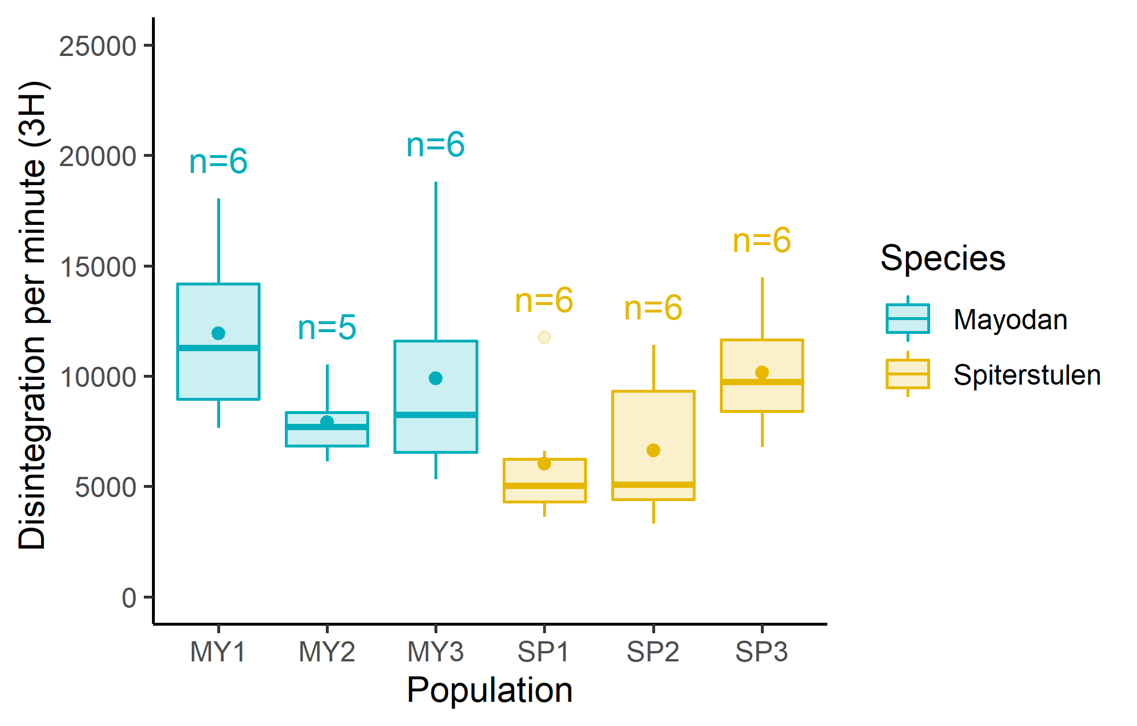

To check the hypothesis of unequal means within the groups ANOVA test is conducted. Its results show that there is a significant difference withing groups on the 10% confidence level. P-value after adjustment almost does not change and is quite close to the 0.05, the level which could have made us more confident concerning the significance of the difference in means.

Table (4) ANOVA results

|  |  |  |  |
| --- | --- | --- | --- |
| **Effect** | **F** | **p-value** | **p-value (adj.)** |
| species | 2.479 | 0.055 | 0.055 |

Tukey post hoc test (see Figure 4) is conducted to see whether any pair of groups shows significant difference in means. However, all the confidence intervals include 0, and hence none of these differences can be treated as significant. Nevertheless, Pairs MY1-SP1 and MY1-SP2 are very close to not capturing the zero. MY1-SP2 group even has a p-value less than 0.1 (see Appendix 3), and thus difference in means for this group can be treated as significant on the 10% confidence level.

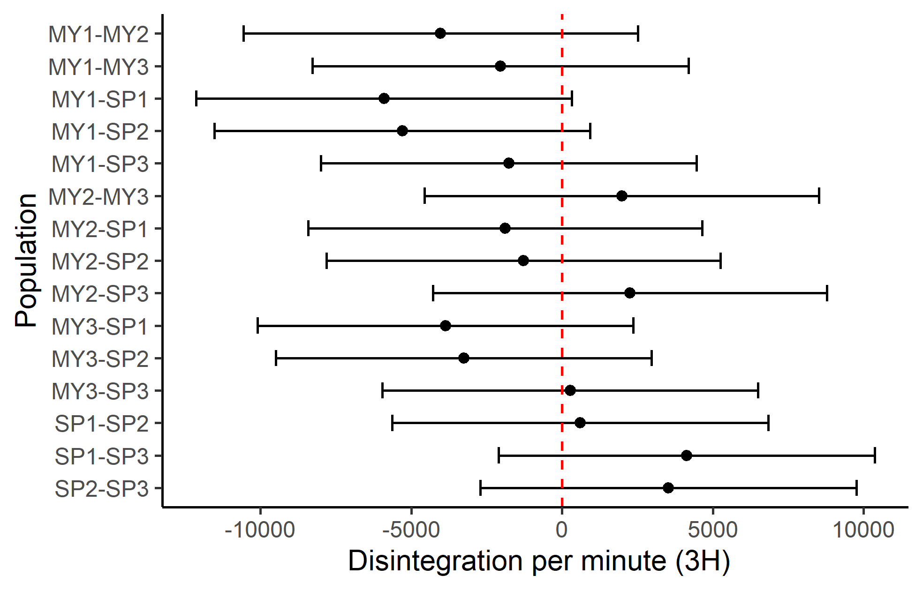

The results of classical pairwise t-test show very alike picture (see Appendix 4). Difference in means for groups MY1 – SP2 and MY1 – SP3 is significant on the 5% confidence level. However, after p-value is adjusted (via FDR method) none of the differences are significant.

**Nested Analysis**

The results of nested analysis are represented further. In such a type of analysis we treat several groups as part of hierarchy. In this particular case we provide three specifications for nested ANOVA analysis. In the first specification Species is the lower level of hierarchy under population (see Table 5). In the other two, population and species are the highest level in the hierarchy, while the lowest is individual id (See Tables 6 and 7).

Table (5): ANOVA – Population/Nested

|  |  |  |
| --- | --- | --- |
| **Effect** | **F** | **p-value** |
| Population | 4.082 | 0.053 |
| Population:species | 2.078 | 0.110 |

Table (6): ANOVA – Population/id

|  |  |  |
| --- | --- | --- |
| **Effect** | **F** | **p-value** |
| Population | 3.533 | 0.070 |
| Population:id | 0.650 | 0.529 |

Table (7): ANOVA – Species/id

|  |  |  |
| --- | --- | --- |
| **Effect** | **F** | **p-value** |
| population | 2.337 | 0.074 |
| Species:id | 0.725 | 0.634 |

In all cases only the higher levels of hierarchy are significant on the 10% level.

Thus, the analysis shows only some evidence of the possible differences in transport of auxin between populations and individual species. However, it’s hard to make any certain conclusions

Appendix 1. Checking for normality and endogeneity for Population

Figure (): qqplot

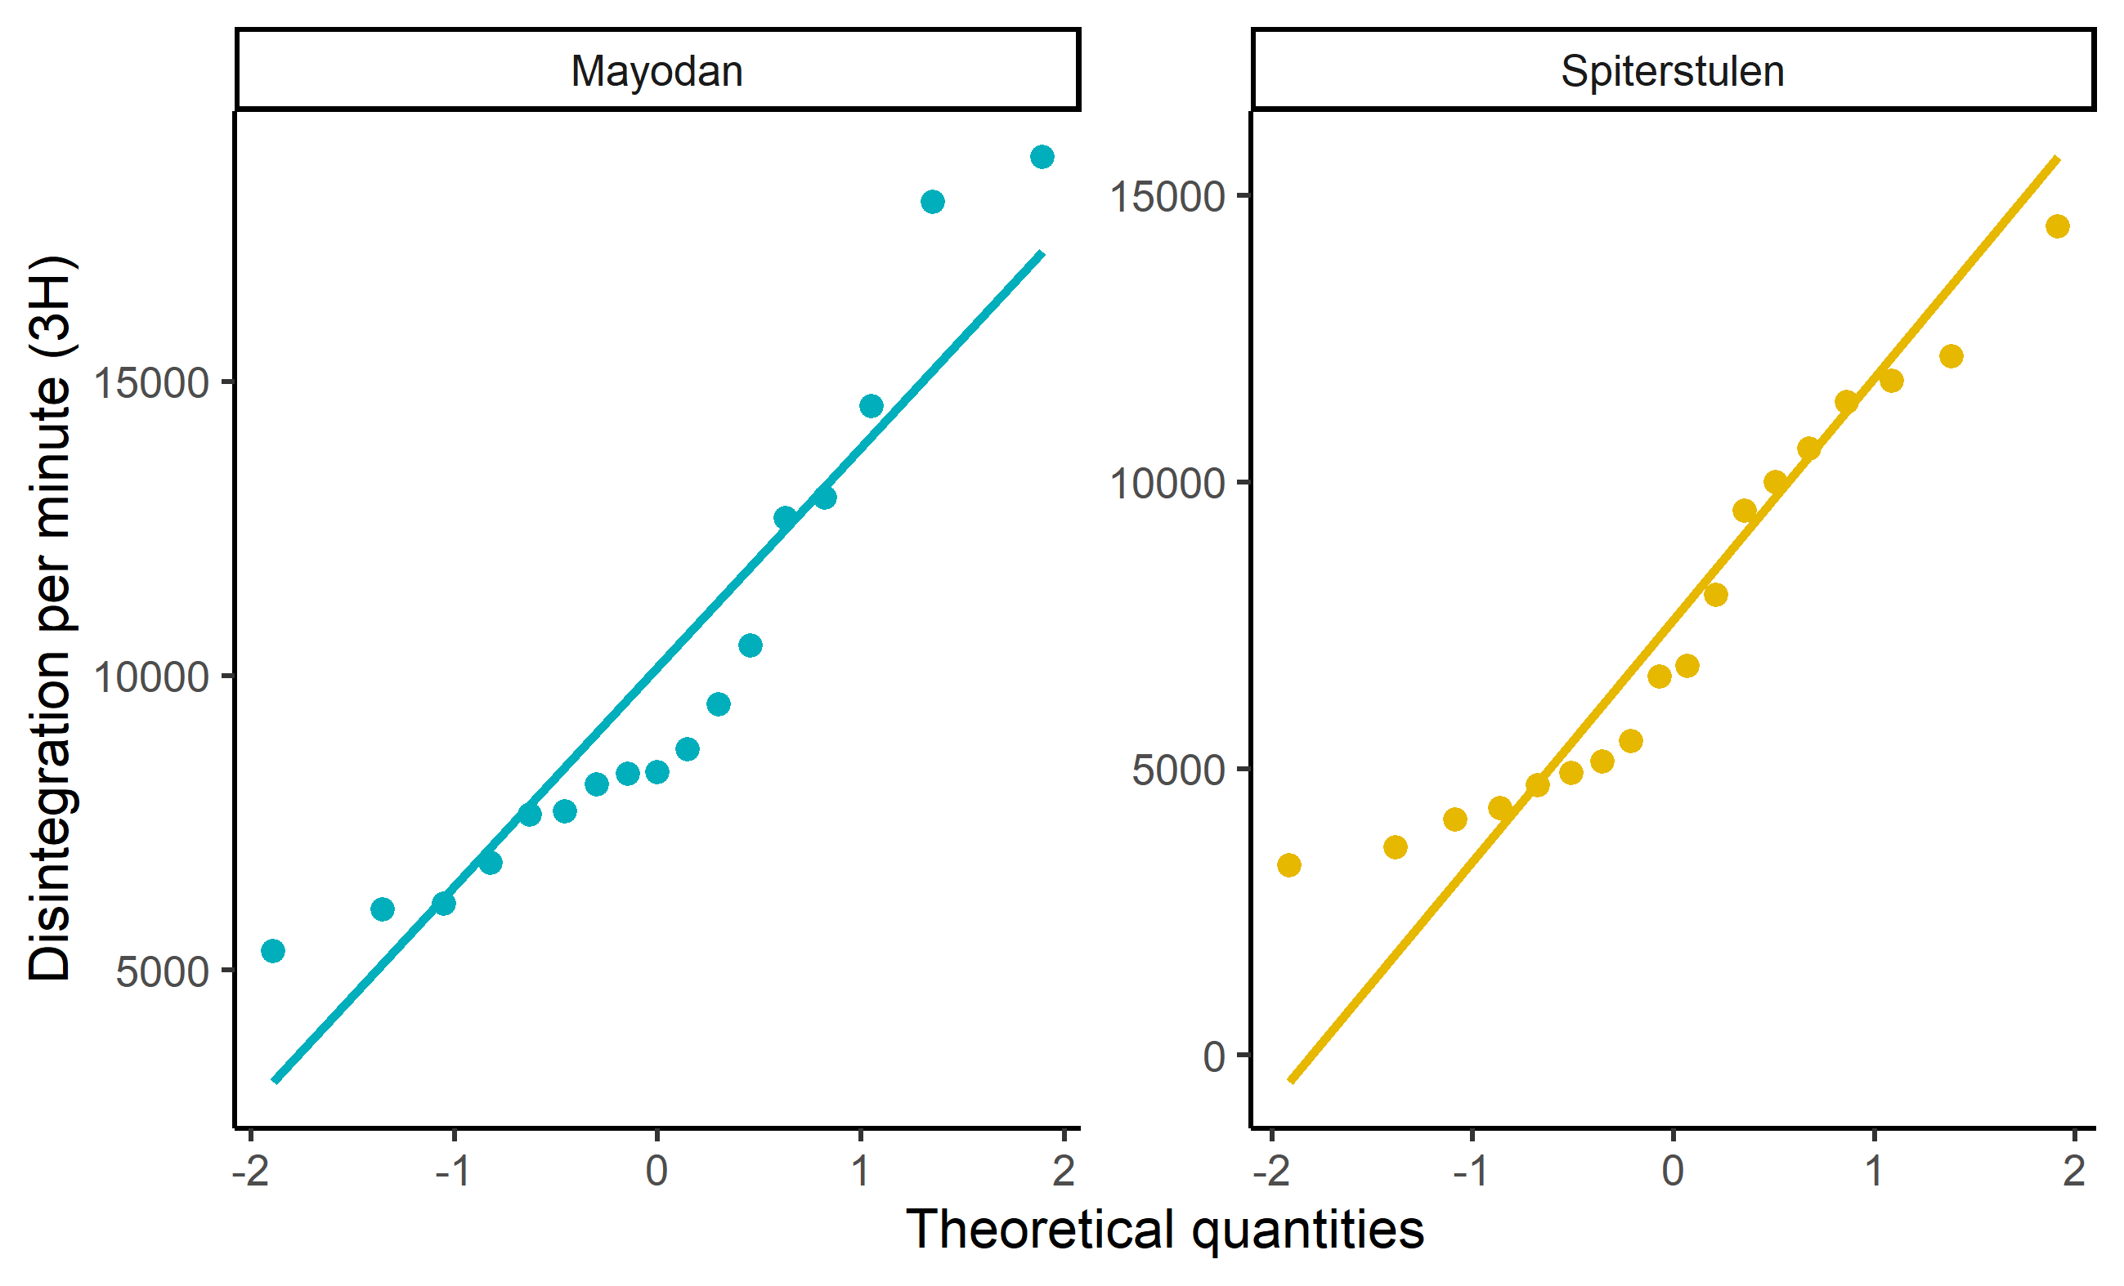

Table () Shapiro Test

|  |  |  |  |
| --- | --- | --- | --- |
| Population | Variable | Statistic | P-value |
| Mayodan | dpm3H | 0.875 | 0.027 |
| Spiterstulen | dpm3H | 0.917 | 0.116 |

Table () Levene’s Test

|  |  |
| --- | --- |
| Statistic | P-value |
| 0.0001666 | 0.990 |

Appendix 2. Checking for normality and endogeneity for Species

Figure (): qqplot

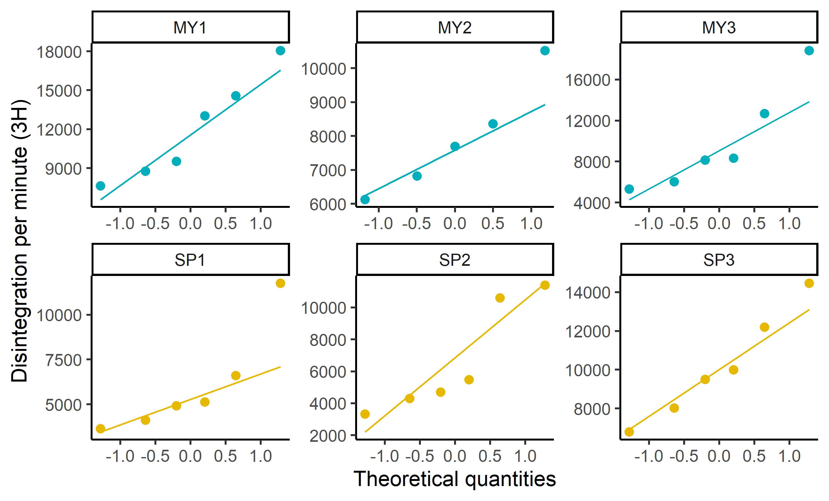

Table () Shapiro Test

|  |  |  |  |
| --- | --- | --- | --- |
| Population | Variable | Statistic | P-value |
| MY1 | dpm3H | 0.933 | 0.604 |
| MY2 | dpm3H | 0.948 | 0.722 |
| MY3 | dpm3H | 0.866 | 0.212 |
| SP1 | dpm3H | 0.791 | 0.049 |
| SP2 | dpm3H | 0.826 | 0.099 |
| SP3 | dpm3H | 0.968 | 0.880 |

Table () Levene’s Test

|  |  |
| --- | --- |
| Statistic | P-value |
| 0.6746619 | 0.646 |

Appendix 3.

Table () Tukey Test Results

| **Term** | **Group1** | **Group2** | **Estimate** | **CI lower** | **CI upper** | **P-value (adj.)** |
| --- | --- | --- | --- | --- | --- | --- |
| species | MY1 | MY2 | -4021.55 | -10554.78 | 2511.6750 | 0.436 |
| species | MY1 | MY3 | -2038.7 | -8267.89 | 4190.4884 | 0.915 |
| species | MY1 | SP1 | -5900.97 | -12130.16 | 328.2234 | **0.0713** |
| species | MY1 | SP2 | -5294.59 | -11523.78 | 934.5984 | **0.132** |
| species | MY1 | SP3 | -1766.24 | -7995.43 | 4462.9484 | 0.952 |
| species | MY2 | MY3 | 1982.85 | -4550.38 | 8516.0827 | 0.937 |
| species | MY2 | SP1 | -1879.41 | -8412.64 | 4653.8177 | 0.949 |
| species | MY2 | SP2 | -1273.04 | -7806.27 | 5260.1927 | 0.991 |
| species | MY2 | SP3 | 2255.31 | -4277.92 | 8788.5427 | 0.896 |
| species | MY3 | SP1 | -3862.27 | -10091.46 | 2366.9251 | 0.428 |
| species | MY3 | SP2 | -3255.89 | -9485.08 | 2973.3001 | 0.609 |
| species | MY3 | SP3 | 272.46 | -5956.73 | 6501.6501 | 1 |
| species | SP1 | SP2 | 606.38 | -5622.82 | 6835.5651 | 1 |
| species | SP1 | SP3 | 4134.73 | -2094.47 | 10363.9151 | 0.354 |
| species | SP2 | SP3 | 3528.35 | -2700.84 | 9757.5401 | 0.526 |

Appendix 4.

Table () Pairwise Test results.

| **Variable** | **Group1** | **Group2** | **n1** | **n2** | **P-value** | **Significance** | **P-value (adj.)** | **Significance (adj.)** |
| --- | --- | --- | --- | --- | --- | --- | --- | --- |
| dpm3H | MY1 | MY2 | 6 | 5 | 0.0707 | ns | 0.212 | ns |
| dpm3H | MY1 | MY3 | 6 | 6 | 0.327 | ns | 0.493 | ns |
| dpm3H | MY2 | MY3 | 5 | 6 | 0.362 | ns | 0.493 | ns |
| dpm3H | MY1 | SP1 | 6 | 6 | **0.00726** | **\*\*** | 0.109 | ns |
| dpm3H | MY2 | SP1 | 5 | 6 | 0.388 | ns | 0.493 | ns |
| dpm3H | MY3 | SP1 | 6 | 6 | 0.0688 | ns | 0.212 | ns |
| dpm3H | MY1 | SP2 | 6 | 6 | **0.0148** | **\*** | 0.111 | ns |
| dpm3H | MY2 | SP2 | 5 | 6 | 0.557 | ns | 0.643 | ns |
| dpm3H | MY3 | SP2 | 6 | 6 | 0.122 | ns | 0.261 | ns |
| dpm3H | SP1 | SP2 | 6 | 6 | 0.769 | ns | 0.824 | ns |
| dpm3H | MY1 | SP3 | 6 | 6 | 0.394 | ns | 0.493 | ns |
| dpm3H | MY2 | SP3 | 5 | 6 | 0.301 | ns | 0.493 | ns |
| dpm3H | MY3 | SP3 | 6 | 6 | 0.895 | ns | 0.895 | ns |
| dpm3H | SP1 | SP3 | 6 | 6 | 0.0523 | ns | 0.212 | ns |
| dpm3H | SP2 | SP3 | 6 | 6 | 0.0949 | ns | 0.237 | ns |